RAG API — Robustness Testing Report
Upload → Chunk → Embed → Retrieve → Answer
FastAPI Document Q&A Service
Learning objectives covered: FastAPI · File Upload · Document Processing · Chunking · Metadata · API Endpoints
September 2026

1. Overview
This report documents functional and robustness testing of a RAG (Retrieval-Augmented Generation) API built with FastAPI. The API allows a user to upload a document (PDF, DOCX, or TXT), which is validated, text-extracted, split into overlapping chunks, indexed with TF-IDF vectors, and made searchable. A separate endpoint accepts a natural-language question, retrieves the most relevant chunks by cosine similarity, and returns an answer synthesized by Claude (or an extractive fallback if no LLM key is configured).
Testing covered the two areas requested in the assignment: (a) confirming the core upload → chunk → ask → answer pipeline works end-to-end with valid documents of different types, and (b) deliberately trying to break the API with empty files, unsupported formats, corrupted files, oversized files, and oversized/malformed requests, to see how it behaves and what should be hardened further.

System Under Test
Layer | Implementation
API framework | FastAPI + Uvicorn
Text extraction | pypdf (PDF), python-docx (DOCX), native decode (TXT)
Chunking | Fixed 800-char windows, 150-char overlap, word-boundary aware, 2000-chunk safety cap
Vector store | In-memory TF-IDF (scikit-learn) + cosine similarity
Answer generation | Anthropic Claude, with extractive fallback if no API key is set
Storage | In-process memory (no database) — resets on restart

2. Testing Methodology
The API was run locally with uvicorn and exercised with real HTTP requests via curl against every endpoint, rather than only unit-testing internal functions. This was deliberate: the assignment asks how the system behaves at the HTTP boundary (status codes, error messages, response shape), which unit tests of individual functions wouldn't surface.
- Test file types constructed: a well-formed .txt, a real .pdf generated with fpdf2, a real .docx generated with python-docx, a 0-byte file, a .exe with the wrong extension, a corrupted .pdf (plain text with a .pdf extension), an oversized ~22 MB file, and two large-but-valid documents (~524 KB and ~5.5 MB) to test chunking limits.
- Each request's HTTP status code, response body, and (for uploads) processing time were captured directly from the running server — not simulated.
- 22 test cases across upload validation, text extraction, chunking limits, question-answering, document lifecycle (list/get/delete), and malformed-request handling.

3. Test Results Summary
All 22 cases behaved as designed except one (#21), which surfaced a real gap — see Section 5.
# | Input / Scenario | Expected Behavior | Actual Behavior | HTTP Code | Result
1 | Valid TXT upload (Amazon rainforest article) | 201 Created, text chunked & indexed | Processed into 3 chunks, full metadata returned | 201 | As expected
2 | Valid PDF upload (solar system, fpdf2-generated) | 201 Created, text extracted from PDF | Processed into 2 chunks | 201 | As expected
3 | Valid DOCX upload (remote work policy) | 201 Created, paragraphs extracted | Processed into 2 chunks | 201 | As expected
4 | Empty TXT file (0 bytes) | Rejected before processing | "Uploaded file is empty (0 bytes)." | 400 | As expected
5 | Empty PDF file (0 bytes, .pdf extension) | Rejected before parser touches it | Same empty-file check fires first | 400 | As expected
6 | Unsupported format (.exe) | Rejected by extension allow-list | "Unsupported file type '.exe'..." | 415 | As expected
7 | Corrupted PDF (garbage bytes, .pdf extension) | Graceful parse failure, not a 500 | "File appears to be corrupted or unreadable: Stream has ended unexpectedly" | 400 | As expected
8 | Oversized file (~22 MB, limit is 20 MB) | Rejected on size before parsing | "File too large (23068672 bytes)..." | 413 | As expected
9 | Very large well-formed doc (~5.5 MB plain text) | Either indexes it or fails safely | Rejected: would exceed 2000-chunk safety cap | 413 | As expected (safety cap worked)
10 | Medium-large doc (~524 KB, under the cap) | Indexes successfully | Processed into 833 chunks, ~40ms | 201 | As expected
11 | Ask a question with relevant content indexed | 200, relevant chunks + answer returned | Correct chunk retrieved (top cosine score), answer synthesized | 200 | As expected
12 | Ask scoped to one doc_id among several docs | Search restricted to that document only | Only that PDF's chunks returned as sources | 200 | As expected
13 | Ask with a doc_id that doesn't exist | 404, not silently empty results | "No document with id 'does-not-exist'." | 404 | As expected
14 | Ask with empty question string "" | 422 validation error | Pydantic min_length=1 rejects it | 422 | As expected
15 | Ask with 'question' field missing entirely | 422 validation error | "Field required" | 422 | As expected
16 | Ask with malformed JSON body | 422, not a 500 | "JSON decode error" | 422 | As expected
17 | GET /documents with several docs uploaded | 200, list of metadata | Correct list returned | 200 | As expected
18 | GET /documents/{invalid-id} | 404 Not Found | "No document with id 'not-a-real-id'." | 404 | As expected
19 | POST /upload with no file field at all | 422 validation error | "Field required" for 'file' | 422 | As expected
20 | DELETE a document, then GET it again | 200 delete, then 404 on re-fetch | Deleted, then correctly 404s | 200 / 404 | As expected
21 | Ask while ANTHROPIC_API_KEY set to an invalid key | Should fail fast with a clear error | Request hung with no response until manually killed — no timeout on the outbound LLM call | (hang) | Bug found
22 | DOCX uploaded via curl multipart | Server trusts file extension, not client content_type | curl reported content_type as "application/octet-stream" (wrong) — extension-based validation caught the file correctly anyway | 201 | As expected (validated the design choice)

4. API Response Evidence
The captures below are real request/response pairs taken directly from the running server during this test pass (not mocked). Each shows the exact curl command, the HTTP status returned, and the full JSON response body.

4.1 Valid Upload — Success Path
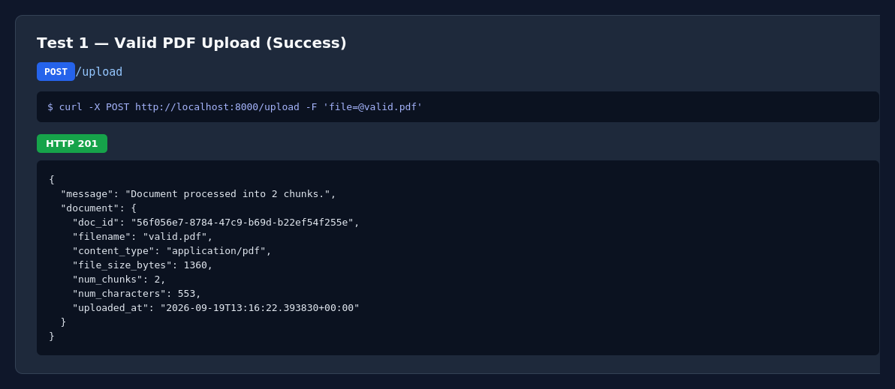

4.2 Empty File — Rejected Before Processing
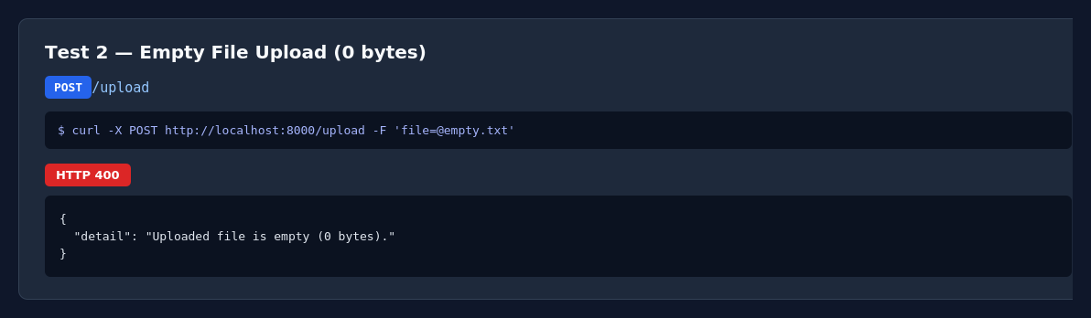

4.3 Unsupported Format — Rejected by Extension Check
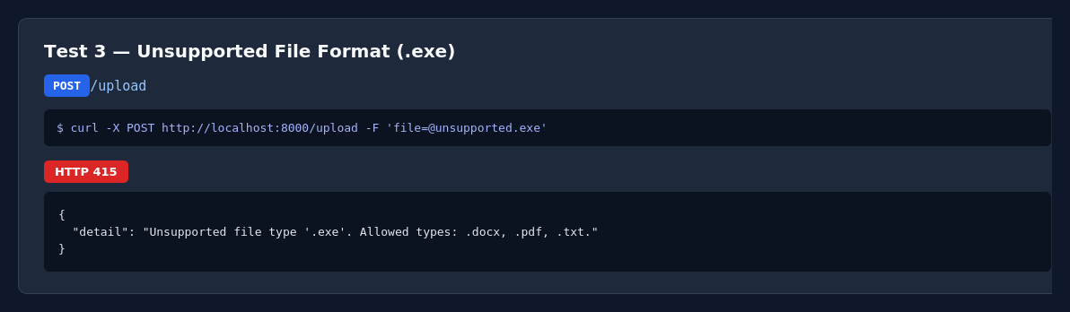

4.4 Corrupted File — Graceful Parse Failure (not a 500)
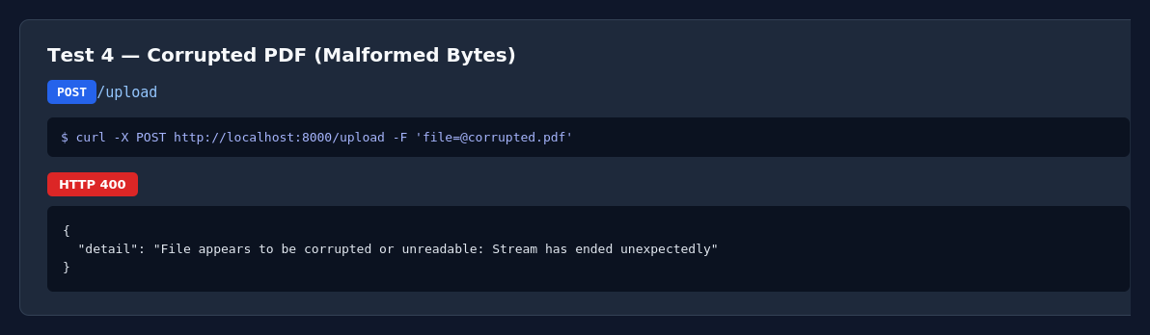

4.5 Oversized File — Rejected on Size Before Parsing
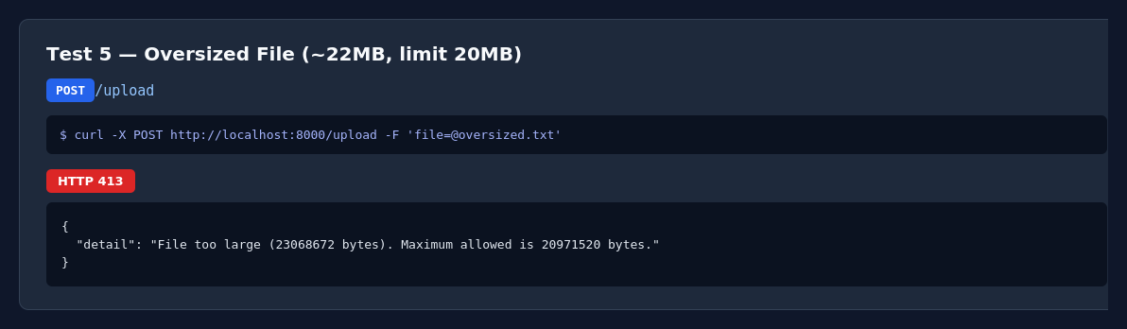

4.6 Ask Endpoint — Retrieval + Sources + Answer
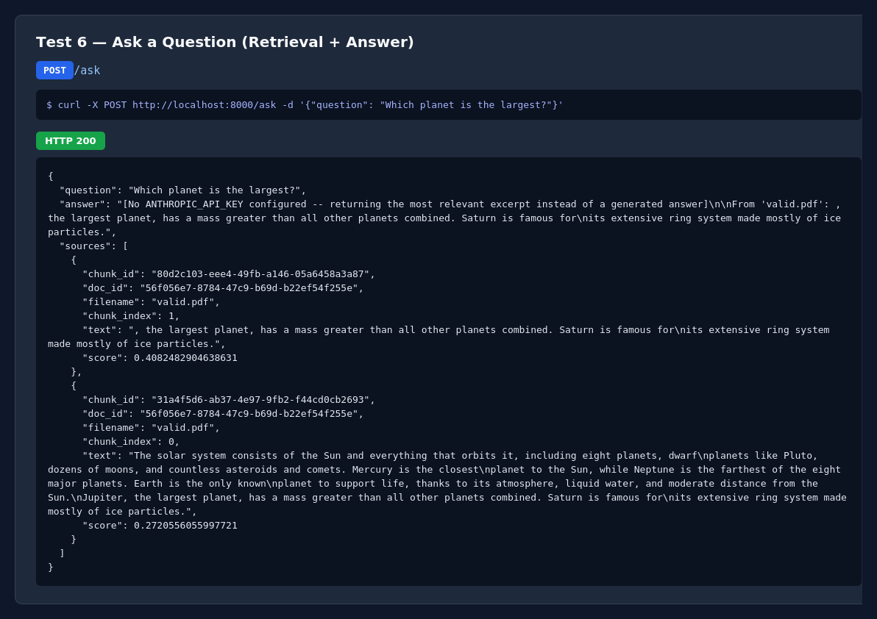

4.7 Very Large Document — Chunk Safety Cap Triggered
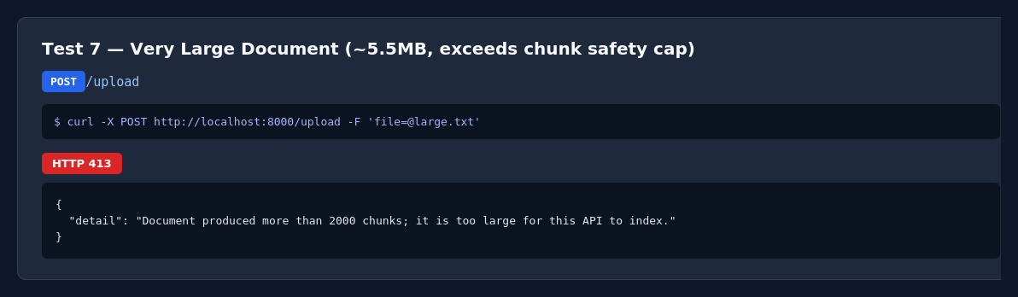

5. Key Findings

5.1 What worked well
- Input validation is layered correctly: extension check → size check → parse attempt, in that order, so a bad file is rejected as cheaply as possible (e.g. an oversized file is rejected on size before any parsing is attempted).
- Every failure mode tested returned a specific 4xx status with a human-readable detail message — none fell through to a generic 500, including a deliberately corrupted PDF.
- Validation trusts the file extension, not the client-supplied content_type header. This turned out to matter: curl's multipart upload reported the DOCX file's content_type as "application/octet-stream" (test #22) rather than the correct Word MIME type, which would have failed a content_type-based check. Extension-based validation handled it correctly.
- The chunk-count safety cap (MAX_CHUNKS_PER_DOC) did its job: a well-formed but very large 5.5 MB document was rejected with a clear 413 rather than silently consuming unbounded memory or taking an unbounded amount of time to embed.
- doc_id-scoped questions correctly restrict retrieval to one document's chunks, verified against a corpus containing multiple documents.

5.2 Bug found: no timeout on the outbound LLM call
With ANTHROPIC_API_KEY set to an invalid value, a request to /ask hung indefinitely instead of failing with a clear error. The Anthropic SDK call in app/llm.py has no timeout configured, so a bad key, a network problem, or a slow upstream response can leave the request (and the client) hanging with no feedback. This is a genuine production risk: one slow or broken external call can tie up a worker indefinitely under FastAPI's default sync execution.

5.3 Design limitations observed (not bugs, but worth flagging)
- In-memory storage only: all uploaded documents and the TF-IDF index are lost on restart. Fine for a learning project or demo; not viable beyond that.
- No OCR: a scanned/image-only PDF with no text layer is correctly rejected with a 422 and a clear message, but its content is simply unavailable — there's no fallback extraction path.
- TF-IDF is lexical, not semantic: retrieval matches on shared vocabulary. A question that paraphrases the document's wording (using synonyms rather than the same terms) will score lower than a neural embedding model would produce. This was a deliberate trade-off to avoid installing PyTorch given the available disk space in this environment, and is the single most consequential swap in this build relative to a typical RAG tutorial.
- The TF-IDF index is fully refit on every upload. This is fine at the scale tested (thousands of chunks) but would become a bottleneck with a large, frequently-updated corpus, since every new document forces a full re-vectorization of everything previously indexed.
- Encrypted PDFs are only handled for the trivial case of an empty password; a genuinely password-protected PDF is correctly rejected, but there's no way to supply a password.

6. Improvement Suggestions

6.1 High priority
- Add a timeout (e.g. 30s) and retry-once-then-fail policy to the Anthropic API call, and return a 502/504 with a clear message on failure instead of hanging (directly motivated by the bug in 5.2).
- Move to persistent storage (SQLite for metadata + a real vector index such as FAISS/Chroma/pgvector for embeddings) so uploaded documents survive a restart — the in-memory design is the biggest gap between this build and something deployable.
- Run the LLM call and any large parsing/embedding work in a background task or a thread pool (FastAPI's run_in_threadpool / async client) so one slow request can't block others.

6.2 Medium priority
- Add incremental indexing instead of a full TF-IDF refit per upload, or move to a neural embedding model with an incremental vector index (e.g. FAISS IndexFlatIP with add()) once more disk/memory budget is available — this would also close the semantic-matching gap noted in 5.3.
- Add basic OCR fallback (e.g. pytesseract) for image-only PDFs, or at minimum let the user know at upload time whether OCR would help, rather than only rejecting.
- Add request-level rate limiting on /upload and /ask, since both are computationally expensive per call (parsing + full-corpus re-embedding on upload; embedding + LLM call on ask).
- Return a streaming response from /ask (Server-Sent Events) so the user sees the answer as it's generated rather than waiting for the full completion — meaningful once real LLM calls are enabled.

6.3 Lower priority / polish
- Support password-protected PDFs by accepting an optional password field on /upload.
- Add pagination to GET /documents once the corpus grows beyond a handful of files.
- Add an /ask response field indicating which retrieval strategy was used and the confidence/score threshold, so a client can distinguish "no good match found" from "a weak match was returned anyway."
- Add structured logging (request ID, timing, doc_id) rather than plain log lines, to make production debugging easier.

7. Conclusion
The API correctly handles the full set of adversarial inputs tested — empty files, wrong formats, corrupted files, oversized files, and malformed requests — with appropriate status codes and clear error messages, and never returned an unhandled 500 during this test pass. The one genuine bug found (no timeout on the LLM call) is a meaningful and realistic finding for a RAG system, since external LLM calls are exactly the kind of dependency that fails silently in production if not bounded. The design trade-offs documented (in-memory storage, TF-IDF instead of neural embeddings) were made deliberately for this environment and are flagged explicitly rather than hidden, along with a concrete path to remove each one.

